### **Docker Project 01**

#### **Project Overview**

In this project, you'll go through all three lifecycles of Docker: pulling an image and creating a container, modifying the container and creating a new image, and finally, creating a Dockerfile to build and deploy a web application.

### **Part 1: Creating a Container from a Pulled Image**

**Objective:** Pull the official Nginx image from Docker Hub and run it as a container.

**Steps:**

**Pull the Nginx Image:**  
docker pull nginx

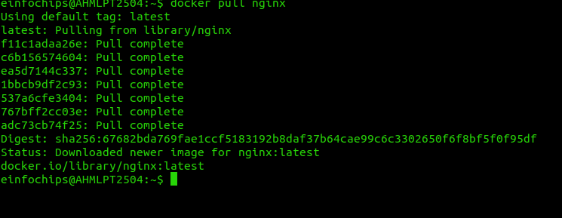

**Run the Nginx Container:**  
docker run --name my-nginx -d -p 8080:80 nginx

* + --name my-nginx: Assigns a name to the container.
  + -d: Runs the container in detached mode.
  + -p 8080:80: Maps port 8080 on your host to port 80 in the container.

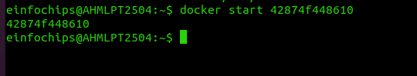

**Verify the Container is Running:**  
docker ps

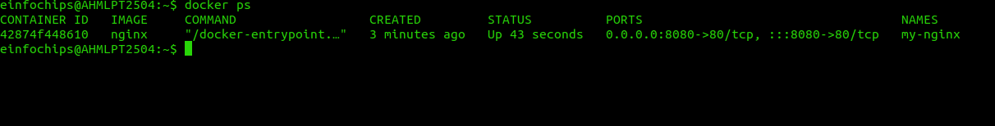

* + Visit http://localhost:8080 in your browser. You should see the Nginx welcome page.

### **Part 2: Modifying the Container and Creating a New Image**

**Objective:** Modify the running Nginx container to serve a custom HTML page and create a new image from this modified container.

**Steps:**

**Access the Running Container:**  
docker exec -it my-nginx /bin/bash

**Create a Custom HTML Page:**  
echo "<html><body><h1>Hello from Docker!</h1></body></html>" > /usr/share/nginx/html/index.html

**Exit the Container:**  
exit

**Commit the Changes to Create a New Image:**  
docker commit my-nginx custom-nginx

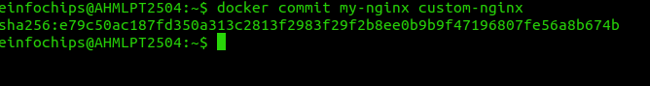

**Run a Container from the New Image:**  
docker run --name my-custom-nginx -d -p 8081:80 custom-nginx



1. **Verify the New Container:**
   * Visit http://localhost:8081 in your browser. You should see your custom HTML page.

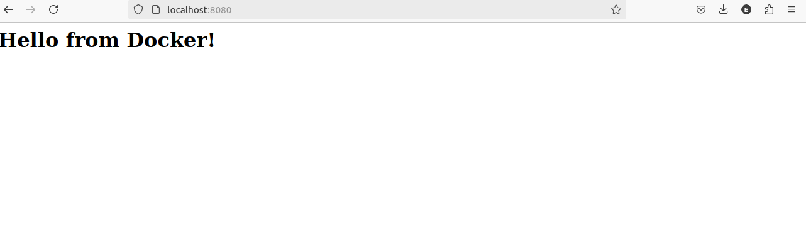

### **Part 3: Creating a Dockerfile to Build and Deploy a Web Application**

**Objective:** Write a Dockerfile to create an image for a simple web application and run it as a container.

**Steps:**

**Create a Project Directory:**  
mkdir my-webapp

cd my-webapp

1. **Create a Simple Web Application:**

Create an index.html file:  
  
<!DOCTYPE html>

<html>

<body>

<h1>Hello from My Web App!</h1>

</body>

</html>

* + Save this file in the my-webapp directory.

1. **Write the Dockerfile:**

Create a Dockerfile in the my-webapp directory with the following content:  
  
# Use the official Nginx base image

FROM nginx:latest

# Copy the custom HTML file to the appropriate location

COPY index.html /usr/share/nginx/html/

# Expose port 80

EXPOSE 80

**Build the Docker Image:**  
docker build -t my-webapp-image .

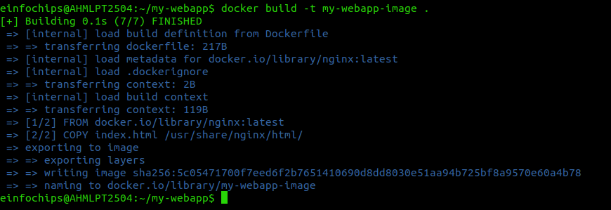

**Run a Container from the Built Image:**  
docker run --name my-webapp-container -d -p 8082:80 my-webapp-image



1. **Verify the Web Application:**
   * Visit http://localhost:8082 in your browser. You should see your custom web application.

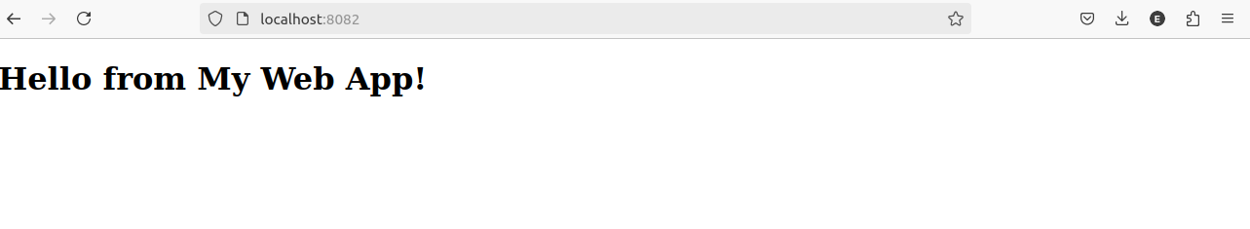

### **Part 4: Cleaning Up**

**Objective:** Remove all created containers and images to clean up your environment.

**Steps:**

**Stop and Remove the Containers:**  
docker stop my-nginx my-custom-nginx my-webapp-container

docker rm my-nginx my-custom-nginx my-webapp-container

1. **Remove the Images:**  
   docker rmi nginx custom-nginx my-webapp-image

**Docker Project 02**

#### **Project Overview**

In this advanced project, you'll build a full-stack application using Docker. The application will consist of a front-end web server (Nginx), a back-end application server (Node.js with Express), and a PostgreSQL database. You will also set up a persistent volume for the database and handle inter-container communication. This project will take more time and involve more detailed steps to ensure thorough understanding.

### **Part 1: Setting Up the Project Structure**

**Objective:** Create a structured project directory with necessary configuration files.

**Steps:**

**Create the Project Directory:**  
mkdir fullstack-docker-app

cd fullstack-docker-app

**Create Subdirectories for Each Service:**  
mkdir frontend backend database

1. **Create Shared Network and Volume:**
   * Docker allows communication between containers through a shared network.

docker network create fullstack-network



* + Create a volume for the PostgreSQL database.

docker volume create pgdata



### **Part 2: Setting Up the Database**

**Objective:** Set up a PostgreSQL database with Docker.

**Steps:**

1. **Create a Dockerfile for PostgreSQL:**

In the database directory, create a file named Dockerfile with the following content:  
  
FROM postgres:latest

ENV POSTGRES_USER=user

ENV POSTGRES_PASSWORD=password

ENV POSTGRES_DB=mydatabase

**Build the PostgreSQL Image:**  
cd database

docker build -t my-postgres-db .

Cd ..

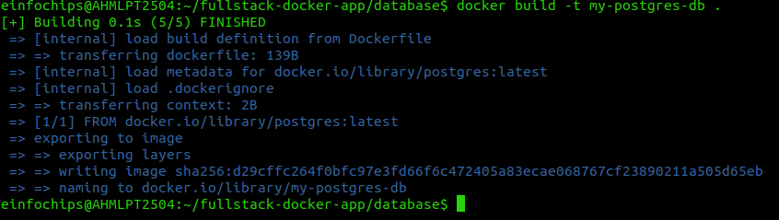

**Run the PostgreSQL Container:**  
docker run --name postgres-container --network fullstack-network -v pgdata:/var/lib/postgresql/data -d my-postgres-db



### **Part 3: Setting Up the Backend (Node.js with Express)**

**Objective:** Create a Node.js application with Express and set it up with Docker.

**Steps:**

**Initialize the Node.js Application:**  
cd backend

npm init -y

**Install Express and pg (PostgreSQL client for Node.js):**  
npm install express pg

1. **Create the Application Code:**

In the backend directory, create a file named index.js with the following content:  
  
const express = require('express');

const { Pool } = require('pg');

const app = express();

const port = 3000;

const pool = new Pool({

user: 'user',

host: 'postgres-container',

database: 'mydatabase',

password: 'password',

port: 5432,

});

app.get('/', (req, res) => {

res.send('Hello from Node.js and Docker!');

});

app.get('/data', async (req, res) => {

const client = await pool.connect();

const result = await client.query('SELECT NOW()');

client.release();

res.send(result.rows);

});

app.listen(port, () => {

console.log(`App running on http://localhost:${port}`);

});

1. **Create a Dockerfile for the Backend:**

In the backend directory, create a file named Dockerfile with the following content:  
  
FROM node:latest

WORKDIR /usr/src/app

COPY package*.json ./

RUN npm install

COPY . .

EXPOSE 3000

CMD ["node", "index.js"]

**Build the Backend Image:**  
docker build -t my-node-app .

cd ..

**Run the Backend Container:**  
docker run --name backend-container --network fullstack-network -d my-node-app

### **Part 4: Setting Up the Frontend (Nginx)**

**Objective:** Create a simple static front-end and set it up with Docker.

**Steps:**

1. **Create a Simple HTML Page:**

In the frontend directory, create a file named index.html with the following content:  
  
<!DOCTYPE html>

<html>

<body>

<h1>Hello from Nginx and Docker!</h1>

<p>This is a simple static front-end served by Nginx.</p>

</body>

</html>

1. **Create a Dockerfile for the Frontend:**

In the frontend directory, create a file named Dockerfile with the following content:  
  
FROM nginx:latest

COPY index.html /usr/share/nginx/html/index.html

**Build the Frontend Image:**  
cd frontend

docker build -t my-nginx-app .

Cd ..

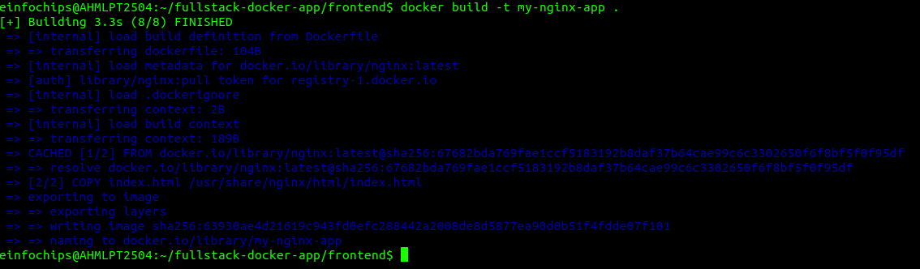

**Run the Frontend Container:**  
docker run --name frontend-container --network fullstack-network -p 8080:80 -d my-nginx-app



**Part 5: Connecting the Backend and Database**

**Objective:** Ensure the backend can communicate with the database and handle data requests.

**Steps:**

1. **Update Backend Code to Fetch Data from PostgreSQL:**
   * Ensure that the index.js code in the backend handles /data endpoint correctly as written above.
2. **Verify Backend Communication:**

Access the backend container:  
  
docker exec -it backend-container /bin/bash



Test the connection to the database using psql:  
  
apt-get update && apt-get install -y postgresql-client

psql -h postgres-container -U user -d mydatabase -c "SELECT NOW();"

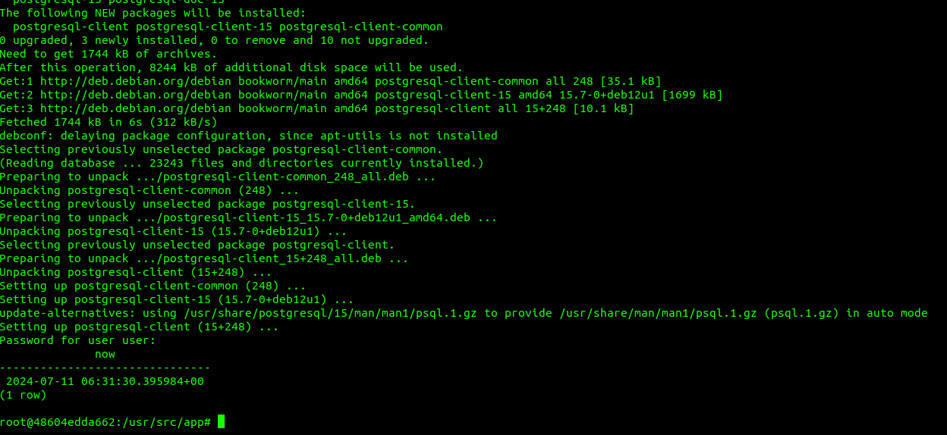

Exit the container:  
  
exit

1. **Test the Backend API:**
   * Visit http://localhost:3000 to see the basic message.
   * Visit http://localhost:3000/data to see the current date and time fetched from PostgreSQL.

### **Part 6: Final Integration and Testing**

**Objective:** Ensure all components are working together and verify the full-stack application.

**Steps:**

1. **Access the Frontend:**
   * Visit http://localhost:8080 in your browser. You should see the Nginx welcome page with the custom HTML.
2. **Verify Full Integration:**

Update the index.html to include a link to the backend:  
  
<!DOCTYPE html>

<html>

<body>

<h1>Hello from Nginx and Docker!</h1>

<p>This is a simple static front-end served by Nginx.</p>

<a href="http://localhost:3000/data">Fetch Data from Backend</a>

</body>

</html>

**Rebuild and Run the Updated Frontend Container:**  
cd frontend

docker build -t my-nginx-app .

docker stop frontend-container

docker rm frontend-container

docker run --name frontend-container --network fullstack-network -p 8080:80 -d my-nginx-app

cd ..

1. **Final Verification:**
   * Visit http://localhost:8080 and click the link to fetch data from the backend.

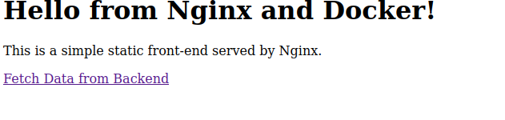

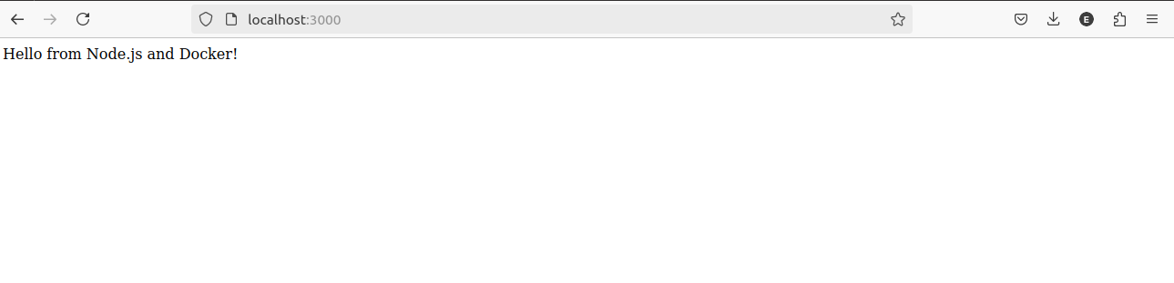

**Part 7: Cleaning Up**

**Objective:** Remove all created containers, images, networks, and volumes to clean up your environment.

**Steps:**

**Stop and Remove the Containers:**  
docker stop frontend-container backend-container postgres-container

docker rm frontend-container backend-container postgres-container

**Remove the Images:**  
docker rmi my-nginx-app my-node-app my-postgres-db

**Remove the Network and Volume:**  
docker network rm fullstack-network

docker volume rm pgdata